XXXXXXdateXXXXXX 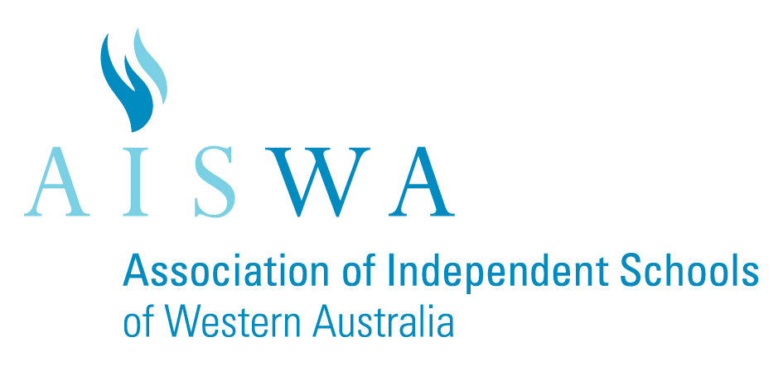

AISWA values cultural and linguistic diversity. Learning Languages supports students to work and live successfully as linguistically and culturally aware global citizens.

AISWA acknowledges the commitment
<Student Name>

has shown in continuing his/her
<Language> language studies through to Year 10
at

<School>

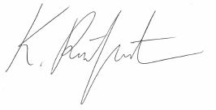
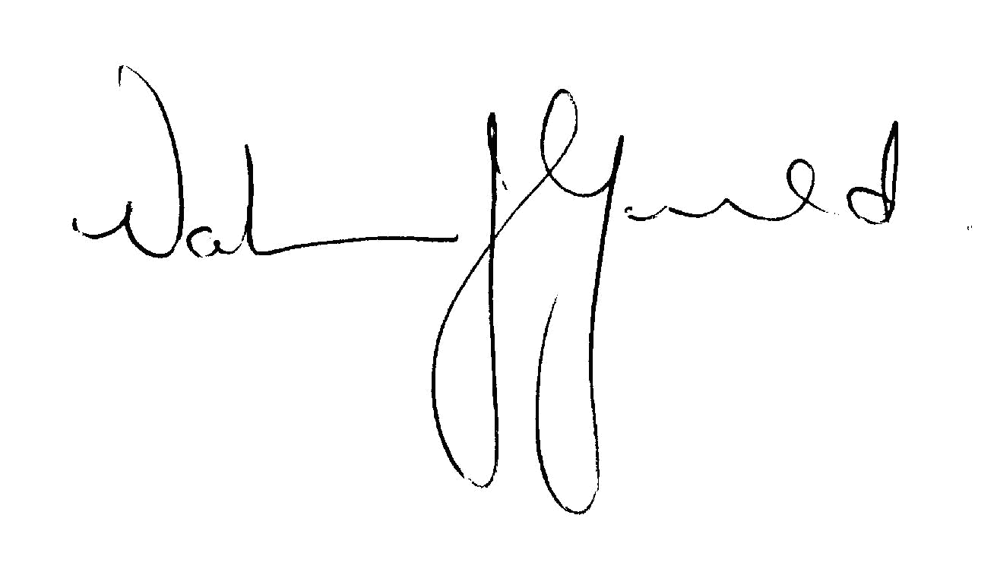

Kate Reitzenstein Valerie Gould
Languages Consultant Executive Director
AISWA AISWA

