Nadine Fraize Immersion Day for French Secondary Teachers

On Thursday 28th May, Nadine Fraize presented a day packed full of ideas for secondary teachers of French hosted at AISWA.
Here is a list of what we learnt today!

(A) Situation
The day began with a snapshot of language teaching in Europe and in particular in Scotland. There they are using the idea of embedding language education into the curriculum and getting all teaching staff on board with it. There is up skilling available for all in addition to well-developed support materials.

(B) Games
Nadine presented a variety of games with different pedagogical goals with a focus on why one should do certain tasks or activities. The reason for doing anything needs to be considered carefully. Why not watch a film for pleasure or read for enjoyment? Languages are about communication and the teacher should consider the choice of tool carefully. If the teacher can do the task better themselves, then do it, you don’t have to use a computer etc. to do that.

One of the first games she presented consisted of small cards with an adjective in its two forms on it. Students are invited to find their opposite by stating ‘who they are”. Je suis grand. Je suis petit etc.
Once a match is found, the group reforms and a game of charades permits the students to guess the pairings. To go further: the students could make more sophisticated sentences etc. In an increasingly technological world, students find the ‘secret’ card and the tactile and physical nature of exploring the room to find a partner, to be stimulating.

Another ‘game’ she presented was to encourage students to tap into their auditory memories and to visualise words. The game was to choose a word, and the first student says what gender it is. Next it is spelt in a round, if a student is uncertain or wrong, they sit out and the spelling of the words begins again. Eventually the word is spelt and you could ask the students to define it in their own words.

(C) Technology
On a technological note, the use of the flip classroom has provided teachers in Scotland with the skills they need to teach. This is equally applicable for our students. The only limit is our imagination. With software such as “Show Me” or “Educreation” the teacher can present a variety of core information to students in advance of the lesson. It can also remediate students or fill in gaps where they were missing.

(D) Sound systems
Nadine also like working with the lists of most popular names for the year in France. Why? You can work on the sounds and spelling in an authentic cultural setting. Pour aller plus loin… make a set of picture cards with a name or an animal. Again, students can move around. Say what you are and find your partner. The name rhymes with the name of the animal! Je suis une chenille, je m’appelle Camille. The students need to match the name with the phonetic sound of the animal.
Cards are made with animals already known but you could write the vocab on the back if you like to enrich or extend their vocabulary. This permits the teacher to work with sounds – an important aspect of speaking a language.

(E) Songs: Nino Ferrer – le telefon (1966)
Nadine introduced a cloze exercise to focus on sounds and rhymes. You can watch video clip and then later fill in cloze activity and alter can change the names and rhymes! There is a karaoke version too. Later the students could make up their own songs with new lyrics. Even adding two new lines to the original version is very amusing. This creates an association of songs with rhymes and rhythm and fun. This higher order aspect of a traditional task adds creativity and interest.

(F) Screenshots
Nadine uses screenshots to make images from videos (with attributions of course from their origin) to support her viewing work. This is practical and quick and easy to do. She likes to take short films or animations that don’t have a dialogue to allow for multi-level utilisations. Nadine points out that although the concepts being discussed may differ, the techniques to exploit the resource are the same. Students watch a video and order the images to reflect the film they have seen. They negotiate the meaning and notice what words they need to explain their choices. This vocabulary is generated by the students themselves and helps them notice what they can say. Then they are given sentences with which to label the images to retell the story. They are ordering and predicting the activity. It is suggested not to use too many cards for the story re-tell.

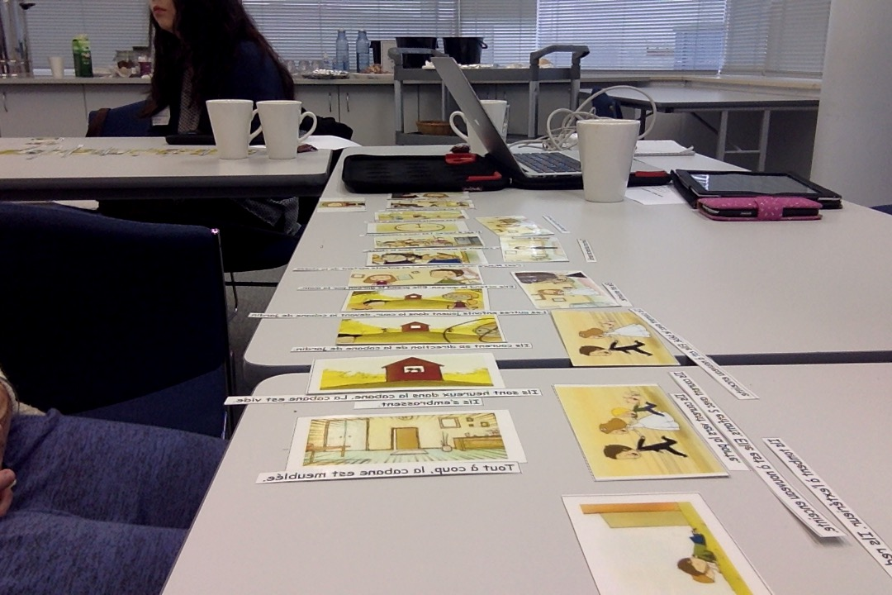

(G) Apps

Applications:
Why not try these?
Chatterkid is an application for ipad that allows you to add audio to a film.
https://www.smore.com/6tgkr-chatterkid (limit of 30 seconds)

30hands - creates an audio and written text and can add arrows and differing colours.
https://itunes.apple.com/us/app/30hands-create-show-what-you/id605013231?mt=8

(H) Measure Progress
Another activity Nadine shared with the group was to use the images and sentences (from the screenshots taken from the video) to pass around the group saying Am Stram Gram etc. Picking a card, the student could give an adjective or a verb or a sentence. They could give a sentence and have to change its tense, they could create a story about it etc. The repetition of use of this resource a year later could help the students to notice and ‘measure’ in a way their own progress. What can they now do with this resource that they could not do before? This idea of a ‘cornerstone’ or continuous activity that carries over allows them to see their own development as learners. This is motivating and an important conceptual activity.

- Mental Gym

In the afternoon the group experienced the mental calculation chain. Each participant took two cards with a number on it. It also contained a small sum to do. When the first person read their question out, the answer was the number on the top of the card and then the person with this answer answered and then, asked the new ‘sum’ on their card. This required the students to do the mental calculations as well as know their numbers.

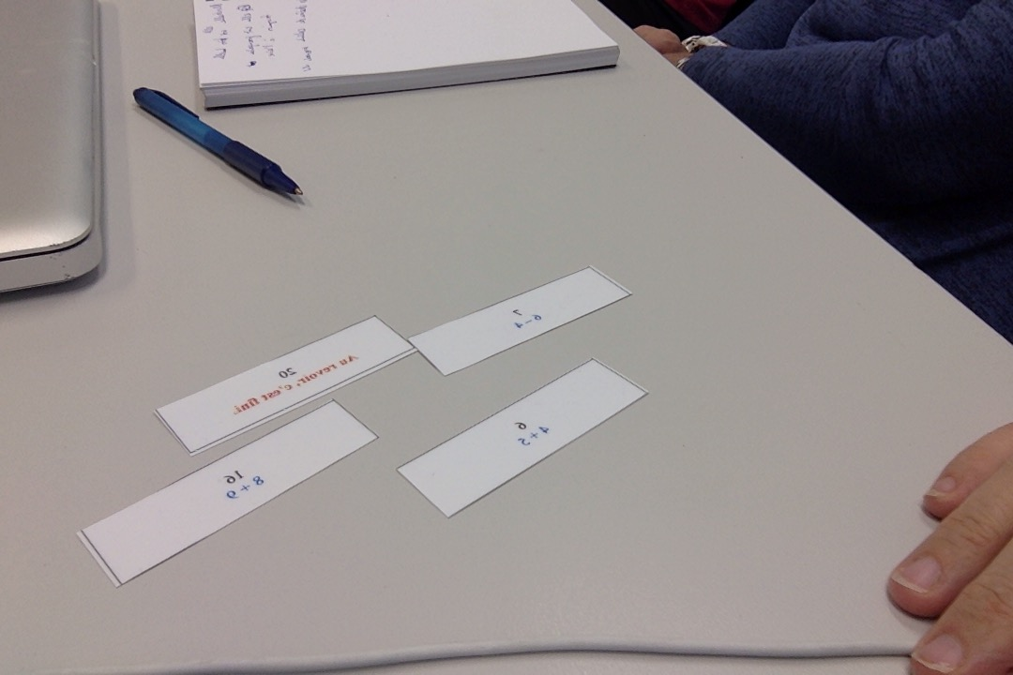

The next activity was a conversational chain with appropriate questions and answers that flow and make sense. Students need to notice when to speak and the numbers on the cut up pieces of conversations help them order the answers. This could then be repeated but with different answers based on personal experience.

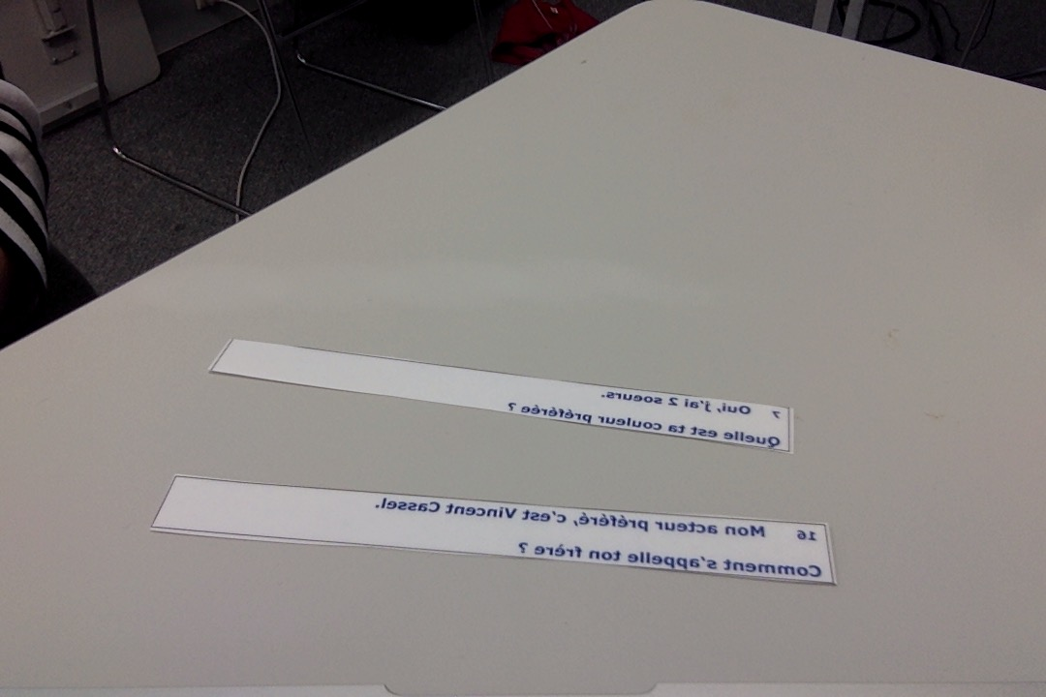
Each time Nadine pointed out how the different age groups could create these resources for themselves or others.

(J) Francophonie
Francophone: Using a variety of maps. By asking questions you can build up a linguistic and geographical ‘leggo’ to enrich and enlarge the vocabulary and knowledge of your students. When presenting families, perhaps you could ask where the grandparents came from. This could lead to an exploration of a geographical knowledge from a new perspective. You could make a little flag and stick it onto a world map to show this knowledge.

http://www.francophonie.org/

Excellent site for further information.

(K) Kahoot
Kahoot
https://getkahoot.com/

This is a game based site that permits the user to set up exciting quizzes and generate information from the responses given. It is highly motivating and allows the teacher to control the delivery of the questions as the students are responding on a separate site to a shape to register their answers. Well recommended, and used in my classroom also!!
Students could watch a video of your choice and make a Kahoot to present and share with their peers.

(L) Semaine de la langue
La semaine de la langue française – to promote and encourage use of the French language.

http://www.dismoidixmots.culture.fr/semainelanguefrancaise/accueil

Nadine presented three short videos about this.
http://www.dailymotion.com/video/x2imtj2

https://www.youtube.com/watch?v=5OrKHooyxIQ

This could provoke lots of great discussion and further work in the secondary classroom.

(M) Flight of the Concords
Fou de Fa fa
Could students make their own parody? Yes!

https://www.google.com.au/search?q=fou+de+fafa&ie=utf-8&oe=utf-8&gws_rd=cr&ei=cLlmVc3yMKHpmQWwk4H4Bw

(N) Advert – Learn French in Paris
https://www.youtube.com/watch?v=eDCoc7_7hOU

Excellent video that could be used in a large numbers of ways for varying levels of students:

Notice basic words. String them into sentences, make a Wordle, retell the story, change tenses, describe what you see, make own story, add dialogue, look for clichés, make own advert about learning English in Perth.

(O) Francophone countries
Find a singer, an artist, a painter, an actor, a sportsman, a politician, a writer, a famous figure etc. Get away from capitals, flags etc.

Could use Kirikou movie.
La chanson de Kirikou
https://www.youtube.com/watch?v=cWriEqWEj60

They don’t need to overly analyse the song, can enjoy it for pleasure and exposure to a French singer and song.
Which language do you want them to do the research in? Depends on ability level. Avoid cut and paste responses from students and ask them good questions.

(P) Twitter (une twictée)

Used more and more in French classrooms for doing dicté. Now being done here rather than on paper. Teacher makes a dicté and then students do it. Then they negotiate amongst them to pick what they think is the best or most accurate one. Once chosen it is twittered to another class to another school. The other school will then correct it.

(Q) Hidden Messages

The teacher has a hidden message printed to show all the students except those sitting in the ‘electric chair’ facing away from the message. The rest of their team members must give information to help them work out what that message is. They may not mime, spell or say the actual words. It is a game of strategy where opposites and paraphrase is involved. A way to permit the differentiation of this game is to have 10 sentences in a bag for them to work through so that the slower groups actually get to play and not give up. There should be a judge to make sure no one cheats!!

(R) Science Lesson (CLIL)

An activity using immersion! (all puns intended!!)

Five fruits were shown; a grape, a lime, a lemon, a kiwi, an apple.
Make groups. Present fruits. Name them and number them. Qu’est-ce que c’est?
Could make two categories for the genders of the words. Do they float or sink? Is it big or small? Heavy or light?
Try the experiment. Any surprises?
Apple and lemon float. It's a question of density, absorption of air and resistance to water, their shape and their air content.

