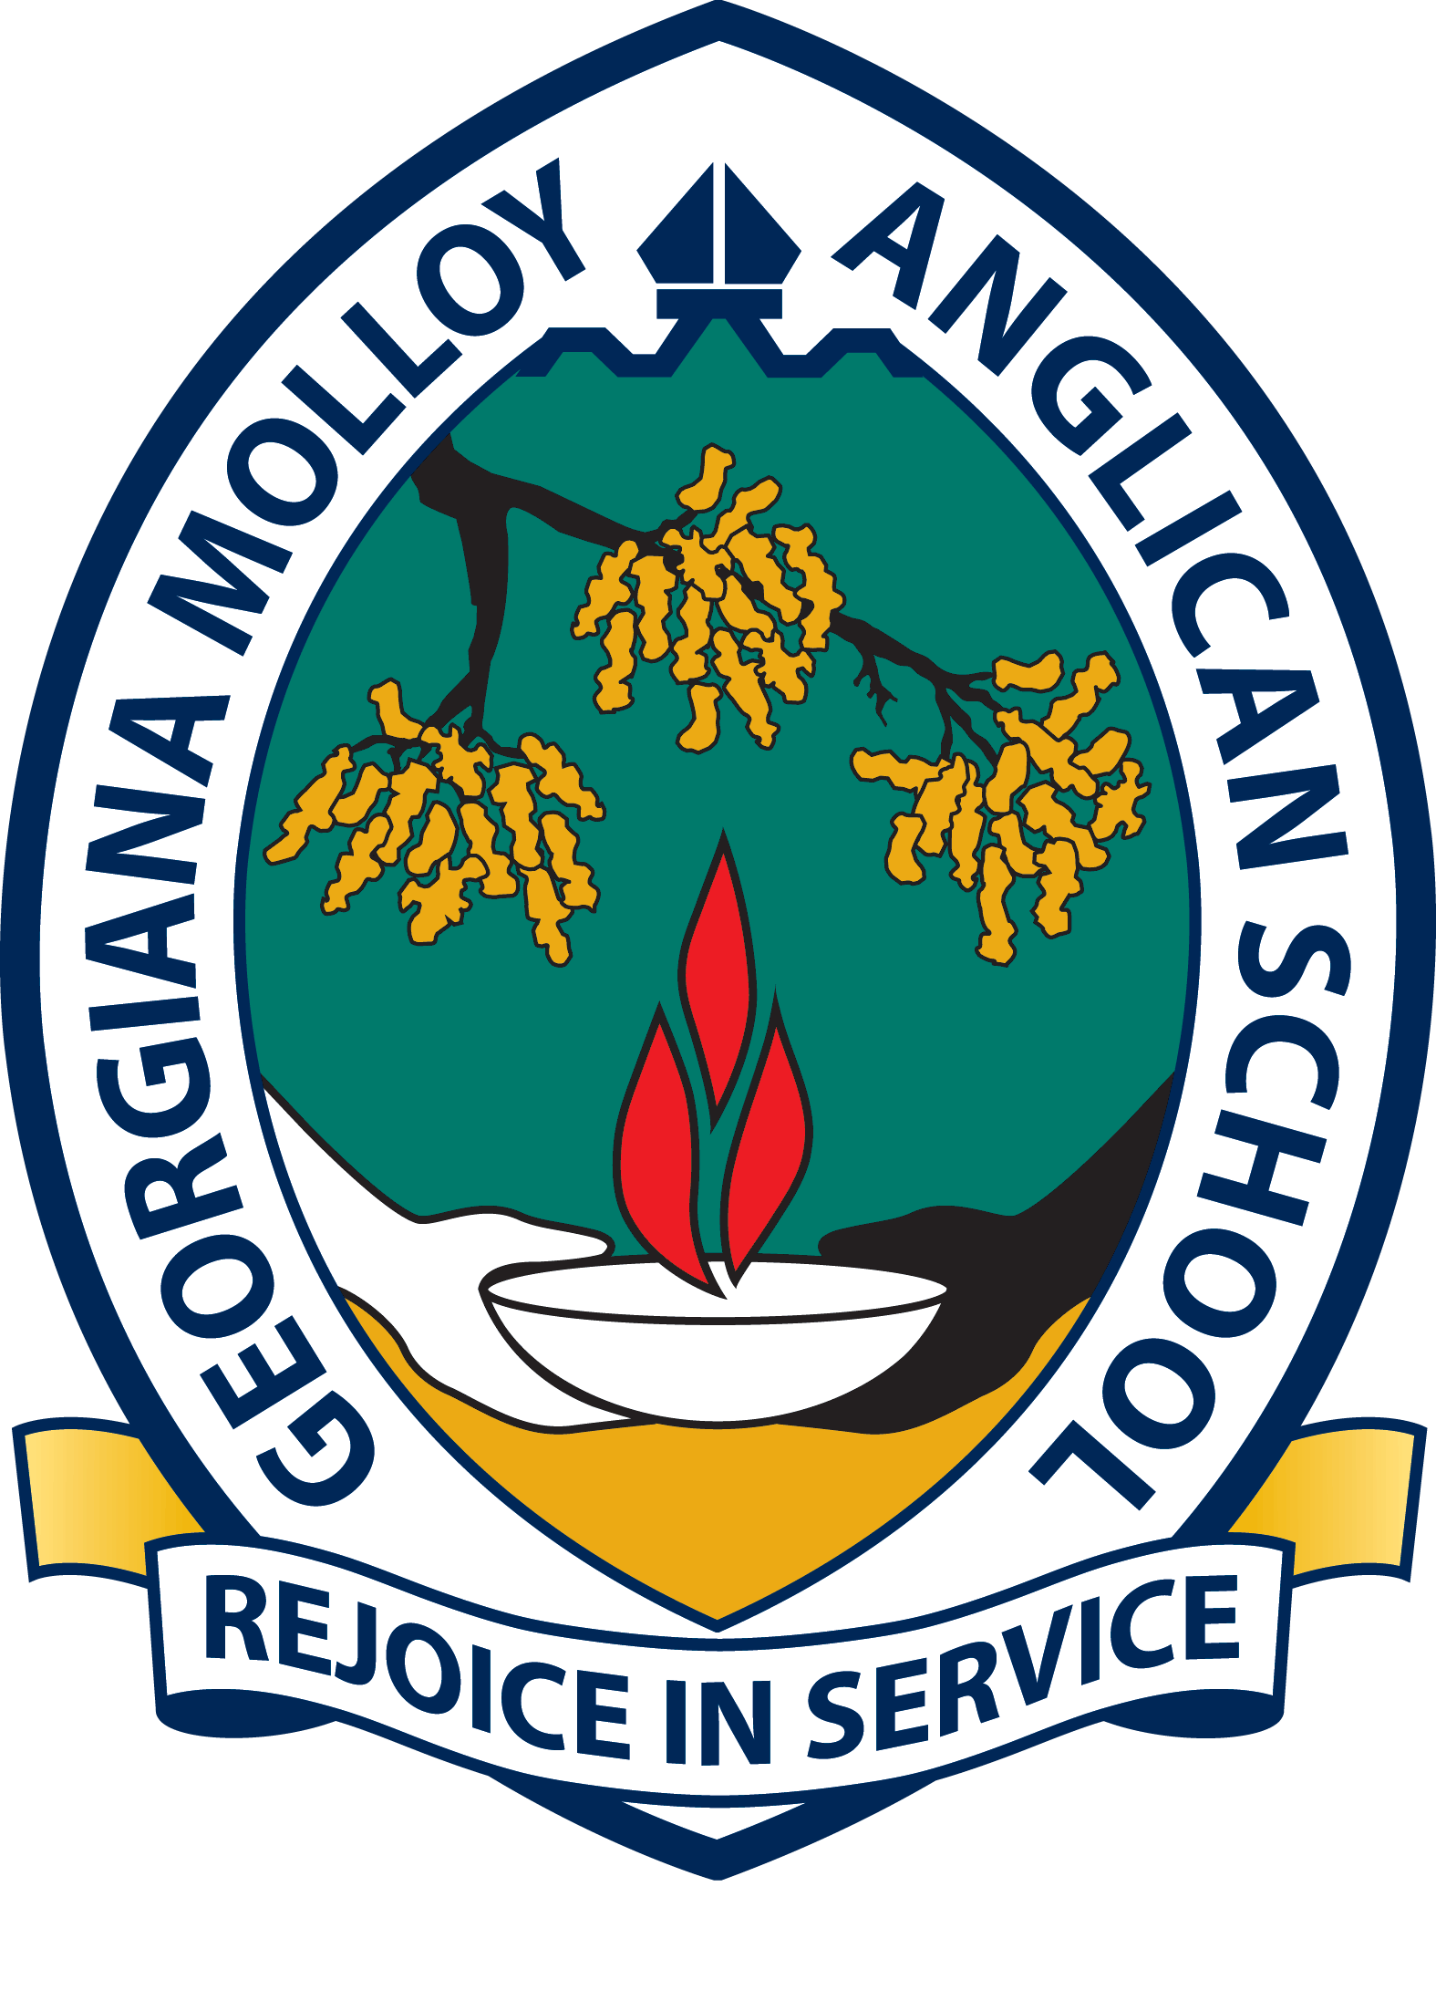
A school of the Anglican Schools Commission (Inc.)
For further information or for a copy of the position description, please visit www.gmas.wa.edu.au and click on “Employment”. Applications should be posted to the Principal, Georgiana Molloy Anglican School, PO Box 920, Busselton WA 6280 or emailed to lha@gmas.wa.edu.au by
4pm Friday 23 October 2015.
AVIATION / MATHEMATICS
SECONDARY ENGLISH
SECONDARY HASS – Maternity Leave
OUTDOOR EDUCATION – Maternity Leave
EARLY CHILDHOOD TEACHERS
Opportunities now… benefits for life
Positions Vacant:
An opportunity to join a leading provider of
education in the South West!

