the Wallal Centenary Celebration
One century ago a large expedition of astronomers from five countries, instigated by the University of Western Australia and supported by Prime Minister Billy Hughes observed an eclipse of the sun that provided definitive confirmation of Einstein’s theory of gravity that remained unbeaten until space experiments of the 1970s.
INTRODUCTION
Einstein-First and the UWA Node of OzGrav will celebrate the centenary of the Wallal Expedition that confirmed Einstein’s theory of gravity, and the birth of gravitational wave astronomy 100 years later. The activities are designed to be of high interest to the public and students.
Instigated by UWA’s foundation professor of Physics and Mathematics, Alexander Ross when the university was housed in tin sheds, the expedition marked the start of a century in which WA made enormous contributions to Einsteinian science including the discovery of gravitational waves and the SKA project, with even bigger space and astronomy projects now on the horizon.
The Australia Tests Einstein Wallal Celebration is several weeks of activities recognising and celebrating science, STEM and Western Australia’s key role in the Wallal Eclipse Expedition. The celebration comprises public and private events, public lectures, and school incursions. A 150-page glossy book designed especially for use in schools will tell the heroic story that all Australians should know. A commemorative coin is being issued by the Royal Australian Mint. Exhibitions will include a science-space-gravity exhibition, a gravity-art sculpture exhibition, the Wallal exhibition, that includes historic photographs, and lectures by an internationally renowned best-selling popular science author and speaker.
ABOUT THE EXPEDITION: 1922
The exhibition in 1922 was a heroic national effort, supported directly by the Prime Minister Billy Hughes, involving leading scientists from USA, Canada, New Zealand, Australia and India. The expedition proved Einstein’s theory of gravity and paved the way for Australia’s later role in proving Einstein’s prediction of gravitational waves for which four Australian scientists won the Prime Minister’s Prize for Science in 2020.
The 1922 Wallal expedition brought worldwide attention to Western Australia. The expeditioners were feted by WA Premier Sir James Mitchell and both Houses of Parliament. The expedition observations took place at a well built by The world’s first scientific documentary was created at Wallal, and shown around the world . The Nyungumarta people provided enormous support, along with the Royal Australian Navy, the Trans Australian Railway and people from Kalgoorlie to Broome. Aviation pioneers Norman Brearley, founder of West Australian Airways and Kingsford-Smith who a few years later completed his legendary flight from the USA to Australia, provided a vital role.
A very similar total solar eclipse will take place at Ningaloo in 2023. Like the Wallal eclipse, the Ningaloo eclipse will be uniquely visible as it crosses the Ningaloo peninsula on April 20, 2023.
CENTENARY CELEBRATION : 2022
A series of seven inter-related events and collaborative activities celebrating the expedition and its impact, showcasing Western Australia’s role, and engaging both public and students in activities linking STEM, arts and culture. Those led by UWA and forming part of this sponsorship request are;
- Centenary Launch Event: The formal program will commence with a launch event to be held at UWA on 21st September 2022. This will include a larger number of guests and several key speakers, including UWA Chancellor, Robert French AC. The book Australia Tests Einstein 1922-2022 (see below) will be launched and a large format banner of the Royal Australian Mint commemorative coin will be unveiled.
The launch will conclude with networking drinks and a tour of the exhibition sculpture and STEM exhibits.

- Wallal Exhibition: Australia Tests Einstein 1922-2022.
This art-science-education exhibition will celebrate the centenary of Wallal , the centenary of Einstein’ receiving the Nobel Prize for the physics of solar panels, and WA’s ongoing role in gravitational wave astronomy. This exhibition at UWA will consist of 8 large panels, a 10-minute video, and be combined with a series of panels about the discovery of gravitational waves. Venue: Winthrop Hall Undercroft, UWA. Some images and text from the exhibition can be seen at https://australia-tests-einstein.weebly.com/about.html

- Gravity Art-Science Sculpture Exhibition: Along with Wallal exhibition, we plan an interactive science exhibition about Einsteinian science, plus a sculpture exhibition of large and medium scale sculptures are inspired by gravitational physics and biology. Distinguished sculptor Mark Grey-Smith instigated the Gravity Discovery Centre science-art exhibition through an exhibition Gravitate held at UWA in the year 2000. This retrospective exhibition will include many new works and will be complemented by works that are part of the Lawrence Wilson art gallery collection. His works (see image) will be located inside the Winthrop Hall Undercroft and beside the UWA reflection pond. In close proximity to the other exhibitions.
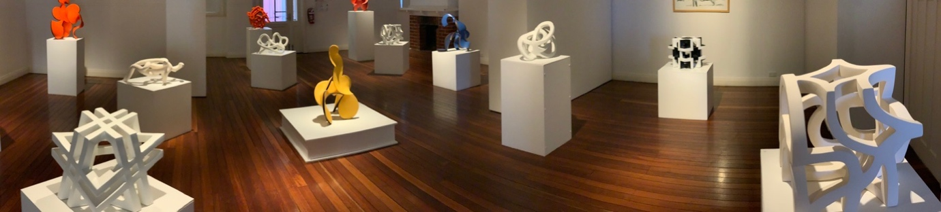

- Einstein-First exhibition on Einsteinian Gravity and Gravitational waves. This will be created and installed by the Einstein-First education project and the Centre of Excellence for Gravitational Wave Discovery. The theme of this exhibition is modern science education for a sustainable future.

- Book: Australia Tests Einstein 1922-2022. The 150-page extensively illustrated book is designed to be suitable for school libraries and public libraries , and is designed to highlight science stories designed to instil pride in Australia’s national scientific endeavours in the context of a remarkable story of scientific struggle and ultimate success.
The book includes the story of Einstein, the struggle to test Einstein’s revolutionary theories, historical photographs of the expedition, and highlights of the discovery of gravitational waves.
- Part 1: Einstein’s Theory and the Wallal Expedition (David Blair and Ron Burman)
- Part 2: The Search and Discovery of Gravitational Waves (David Blair)
- Part 3: Founding NEMO: the future of gravitational wave astronomy (Paul Davies)
The book will be distributed via School libraries, tourism outlets, Scitech, WA Museum and Broome.
- Schools Lectures and Public lectures: UWA will host a series of public lectures and schools’ lectures. Some of these will also be streamed on YouTube video. Series of Schools lectures, five days, 9-11am 2 each day in the Ross Lecture Theatre, and other venues, on exciting modern physics topics: quantum computers, black holes, dark matter, gravitational wave astronomy, and also Einsteinian physics talks and workshops for schools.

- High-profile International Speaker: Commitment has been secured from bestselling science author, Professor Paul Davies AM to speak in a public event in Perth CBD plus one or more lectures at UWA, and potentially in a visit to the Gravity Discovery Center. Prof Davies is Templeton Prize Winner, Winner of two Eureka prizes, the Faraday Prize and the Kelvin Prize. He has a very large public following globally, has appeared as a keynote speaker at high profile events and on tv documentaries so is certain to attract large audiences; physical, social media and video. His attendance is pending securing sponsorship. https://en.wikipedia.org/wiki/Paul_Davies

Additional Events with Additional JTSI Sponsorship

- Science, STEM & Culture International Speaker Event. There have been discussions to host a public event in the Perth CBD featuring Paul Davies as the keynote speaker. To be held at the Art Gallery of WA, Museum, Town Hall or similar venue. Like the other main events, this would promote the Wallal Centenary Celebrations and the Visit WA 2023 Solar Eclipse.

- Perth Night Skies Week. There have been discussions for a ‘night skies’ viewing event and talk to be operated by the Gravity Discovery Centre, in collaboration with Einstein-First to be held on the roof top of the Art Gallery of WA. This would be held a month prior to the main activities. The event would promote the Wallal Centenary Celebrations and the Visit WA 2023 Solar Eclipse.

