

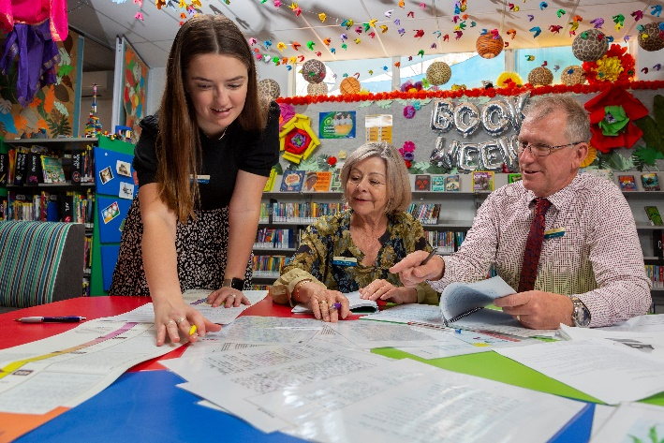

Brightpath Community PL Event

More schools are using Brightpath more often and there is much that we are learning from each other. From time to time, we organise a community PL to bring schools together to share their experiences, insights and advice.

We have a wonderful, diverse session organised for the 31 March.

Reflecting on our school’s approach to implementing Brightpath

Join us as principals, curriculum leaders and teachers share their successes, failures and tips.

Presenters:

Tammy Paterson | Knox Grammar School, NSW
Samantha Turrell | Spring Hill Primary School, WA
Christine Pitman | Salvado Catholic College, WA

And much more… There will be plenty of time for questions and discussion.
So come along and get tips and advice that will help you in your school.
Date: | Thursday 31 March, 2022
Time: | 1.00 – 2.00 Perth  2.30 - 3.30 Darwin  3.00 - 4.00 Brisbane  3.30 – 4.30 Adelaide  4.00 – 5.00 Sydney, Melbourne Canberra
Location: | Online streaming – your zoom link will be sent prior to the event
Register your interest:  Free admission | https://www.stickytickets.com.au/tlzj7

Please email susan@brightpath.com.au for any inquiries.

