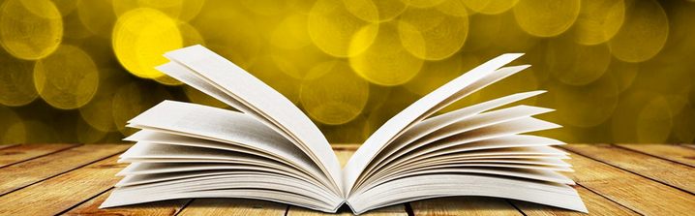
The Children’s Book Council of Australia WA Branch (Inc.)
2019 CBCA Book of the Year Awards
Judges Talk and Short List Discussion
CBCA Judges Anne Marie Strother (Older Readers) and Felicia Harris (Younger Readers), and CBCA WA Branch members will discuss the
2019 CBCA Book of the Year Awards Short List
Wednesday 24th April
Oasis Lotteries House
37 Hampden Road Nedlands
6.30 for 7pm start to 9.00pm
Light refreshments provided
Professional Learning certificates are available on request
CBCA members $5 / Non-members $15
https://www.trybooking.com/BBQJK
Please book by Friday 19th April
Places limited – book early to avoid missing out
For further details, contact:
Felicia.Harris@education.wa.edu.au
gailspiers@iinet.net.au
