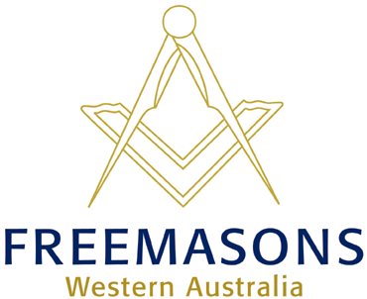
THE GRAND LODGE OFFICE
61 Thomas Street Subiaco WA 6008
PO Box 929 West Perth WA 6872
Tel: 08 9355 3599
Fax: 08 9355 4902
grandsec@freemasonswa.org.au
freemasonswa.org.au
SPEAK UP AWARDS 2021

Welcome to you all. Pandemic permitting, the Speak Up Awards sponsored by the Grand Lodge of WA Freemasons will be held this year.

All heats will be held in August, with the preliminary finals at the Scarborough Masonic Hall, 193 Hancock Street, Doubleview and the final at the Lawley Park Village Community Centre, 55 Alexander Drive, Menora.
As with last year, there are important points to note:
- The closing date for entries without names but with payment is 5pm Friday 7th May;
- The closing date for names is Friday 2nd August.
- Up to three students per school, from Years 4, 5 or 6, at an entry fee of $20 per student.
- The required tax invoice is included in the Speak Up package (see below).
- Students may discuss their heat performances with adjudicators, but individual marks will not be provided at any stage.
- Power point or similar presentations are not permitted.
- The use of microphone/amplifier equipment is not permitted UNLESS it is essential for sound effects – in which case the competitor SHALL provide his/her own equipment.

 | AREA | DATES | LOCATION
Heats | Peel Region  South-West  Metropolitan area | 9 August  August TBA  9-10-11 August  16-17-18 August  23-24-25 August  (spare) | Furnissdale Masonic Centre  Furnissdale Road Furnissdale  Busselton Masonic Centre  West Street Busselton  Scarborough District Masonic Hall  193 Hancock Street Doubleview
Preliminary Finals | All districts | 30-31 August  1 September (spare) | Scarborough District Masonic Hall  193 Hancock Street Doubleview
Final | All districts | 17 September | Lawley Park Village Community Centre  55 Alexander Drive Menora
A package of entry forms and all relevant information will be e-mailed to schools and colleges that register their interest. For general information, speech preparation, presentation and adjudication are the same as before. An early indication of interest would be appreciated. To indicate your interest or seek further information, please contact:
- Geoff Paddick, Coordinator 61618721 or gmpaddick@yahoo.com.au
- Cherie Evans, Grand Lodge 9355 3599 cherie@freemasonswa,org.au
SPEAK UP AWARDS is a community project of The Grand Lodge of WA Freemasons.

