Scouts WA Recycling – a new social enterprise for the Containers for Change Scheme
Containers for Change is the WA Government's new container deposit scheme commencing across WA on Tuesday 2 June, 2020. The scheme will promote recycling, improve the environment, reduce waste going to landfill, and create employment.
Scouts WA has established a new social enterprise, Scouts WA Recycling, that can help your school raise funds when the scheme starts by providing an easy and convenient no-cost collection and refund service. A 10-cent refund will be payable on each eligible beverage container (aluminium cans, glass and plastic bottles, LPB juice packs) returned to a refund point such as a Scouts WA Recycling depot.
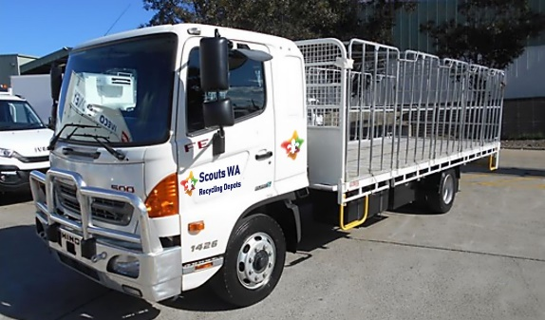
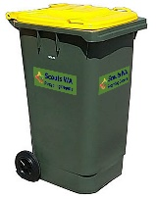
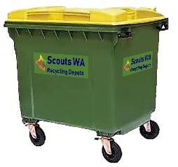
Scouts WA Recycling will initially have a network of four refund point depots across the Perth metropolitan area. The depots will provide up to 40 new jobs, with a focus on providing employment for people with disabilities, long term unemployed, indigenous employment, and youth employment pathway entry. Revenue generated by the new social enterprise will be returned to the community through Scouts WA youth development programs.
The Scouts WA Recycling depot network will include a fleet of commercial vehicles that can provide a no-cost collection service to your school. Scouts WA Recycling will provide suitably sized bins to your school and collect them, either on demand or on an agreed regular collection cycle, for processing at our closest depot.
Scouts WA Recycling will count your containers and enter the count in the Scheme database against your school’s Scheme ID. Payment of refund amounts will be made directly from the Scheme to your school by EFT. You will be able to register your school on the Scheme website as a participant to receive a Scheme ID in the lead up to commencement on 2 June 2020. You can also choose to donate your refund amounts either to Scouts WA or another community or charity organisation.
Containers placed in kerbside recycling and commercial waste collection bins give the refund to the commercial waste industry. Putting your eligible containers in a Scouts WA Recycling bin will ensure you receive your refunds and reduce the volume of commercial waste removal.
Containers for Change is an opportunity for your school to raise funds through refunds on drink containers already in your waste. This opportunity can be extended by encouraging your local community to donate their used containers to your school. Scouts WA Recycling offers you a convenient, no-cost service that will ensure you receive refunds for as many eligible containers as you can collect.
If you would like to know more about the service and your school is north or east of the river contact Greg Campbell on 0431 925 381 or Brian Witkin on 0408 922 295, and for south of the river contact Stuart Howlett on 0487 686 173, or for email contact gregc@scoutswa.com.au .

