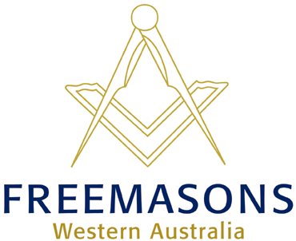
THE GRAND LODGE OFFICE
61 Thomas Street Subiaco WA 6008
PO Box 929 West Perth WA 6872
Tel: 08 9355 3599
Fax: 08 9355 4902
grandsec@freemasonswa.org.au
www.freemasonswa.org.au

SPEAK UP AWARD 2017
The Grand Lodge of WA Freemasons is delighted to announce that the Speak Up Award will resume this year after circumstances forced its postponement last year.
The Speak Up Award is a public speaking competition for Years 4, 5 and 6 students.
It is sponsored and conducted by the Grand Lodge of WA Freemasons.

This is preliminary advice to schools and colleges in the Metropolitan Area and Peel Region of the Speak Up Award 2017, so that the competition can be included in class programs.
- Round One, Peel Region, will be held at the Furnissdale Masonic Centre in Furnissdale;
- Rounds Two and Three and the Preliminary finals will be held at the Scarborough District Masonic Hall, 193 Hancock Street, Doubleview;
- The Final will be held at the Lawley Park Village Community Centre.

Other important points to note:
- Closing date and time for receipt of all entries is 5pm Friday 16 June 2017.
- Schools may nominate up to three students from Years 4, 5 or 6 at an entry fee of $20 per student.
- Grand Lodge will provide the required tax invoice.
- Students may discuss their heat performances with adjudicators, but individual marks will not be provided at any stage.
- Power point or similar presentations are not permitted.
- The use of microphone/amplifier equipment is not permitted UNLESS it is essential for sound effects accompanying the speech – in which case the competitor shall provide his/her own equipment.
STAGE | AREA | DATES | LOCATION
Round One | Peel Region | !8-19 July | Furnissdale Masonic Centre  Furnissdale Road, Furnissdale
Round Two | Metropolitan Area | 1-2-3 August | Scarborough District Masonic Hall  193 Hancock Street Doubleview
Round Three | Metropolitan Area | 8-9-10 August | Scarborough District Masonic Hall  193 Hancock Street Doubleview
Preliminary Final | All districts | 28-29 August | Scarborough District Masonic Hall  193 Hancock Street Doubleview
Final | All districts | 20 September | Lawley Park Village Community Centre  Alexander Drive Mt Lawley

A package of entry forms and all relevant information will be e-mailed to schools and colleges by Monday 24 April. For general information, speech preparation, presentation and adjudication are the same as before. An early indication of interest would be appreciated.
To indicate your interest or seek further information, please contact:
- Geoff Paddick Coordinator 61618721 or gmpaddick@yahoo.com.au
- Cherie Evans, Grand Lodge 9355 3599 cherie@freemasonswa,org.au
SPEAK UP AWARD is a community project of The Grand Lodge of WA Freemasons

