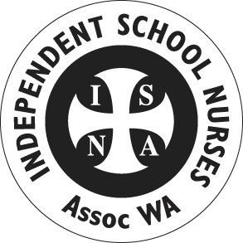
Information Sheet

- Objectives of the Independent School Nurses Association WA
To promote the provision of an optimum standard of health care in all Independent Schools by:
- Providing and promoting educational opportunities to ensure members are suitably trained and are following current practices
- Encouraging consultation and cooperation between member schools and colleges
- Collecting and circulating information relative to the specialty of school nursing, schools in general and independent schools in particular
- Promoting discussion and networking amongst members and member schools
- Conducting and or encouraging particular in seminars, conferences, and in-service activities in accordance with Continuing Professional Development requirements
- Liaise, cooperate and maintain harmonious working relationships with Independent School Associations, other appropriate bodies and allied health professionals
- Promote and encourage ethical standards of conduct and practice in accordance with competency standards as determined by the Nursing and Midwifery Board – ARPRHA

- General meetings are held in Term 1, 2 and 3.
- Annual Study Day and the Annual General Meeting is held Term 4.
- End of year gathering held in Term 4.
- School Nurses and First Aid Officers are eligible to join. Further details available from the ISNA WA Constitution.
- Annual membership is $25 and includes the general meetings, discounted Annual Study Day registration fee and access to other members via email for support
2018 Committee
President: Mandy Perrignon, St Hildas 9285 4500
Treasurer: Phoebe Robinson, PLC 9424 6432
Secretary: Kate Buffham, Mercy College 9247 9216 Kate.Buffham@cewa.edu.au
Education Officers: Natalie Speer, Hale 9347 0112
Carmel Pauley, St Hildas 9285 4235
For further information contact any committee member

