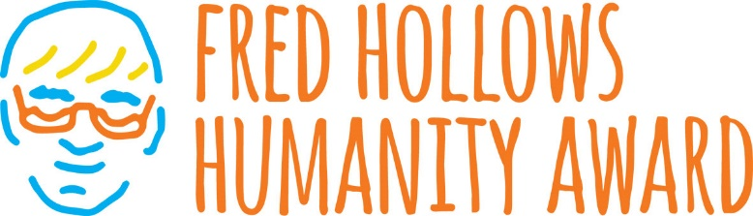

Award to recognise students following in Fred Hollows’ footsteps
The Fred Hollows Foundation is calling for teachers, parents and community members to nominate students for the Fred Hollows Humanity Award.
The award recognises Year 6 students who show compassion, integrity and kindness in their lives, just as Fred did. Nominations open Monday 24 July and close Sunday 10 September.
Award recipients will be recognised at a state presentation ceremony where a Junior Ambassador to The Foundation will be announced. This Ambassador will extend their humanity by allocating $5000, donated by Specsavers, to a Fred Hollows Foundation program of their choice to help end avoidable blindness.
To nominate a student go to www.hollows.org/humanityaward

