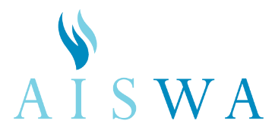

For Bulletin

AISWA Services Survey
As part of the Association of Independent Schools of Western Australia's (AISWA) pursuit of continual improvement and best practice, the AISWA Board wishes to obtain research informed views and insights regarding the current services provided as well as possible areas that should be considered for future strategies. To gain feedback, members and other persons who have utilised or been involved with AISWA's services will be invited to complete an online questionnaire.

The research will be conducted by MMG Education, a leading Australian educational consultancy that works with over 230 schools in Australia, New Zealand and Asia.

To ensure confidentiality and to encourage frank and full expression of views:
- All responses will be treated by MMG Education in strict confidence
- No respondent will be identified to AISWA by MMG Education on the basis of responses made
- All data collected by MMG Education will remain under its control and archived according to professional research protocols

The questionnaire is extensive and will cover the full range of our services, events and activities as well exploring your interest in future services.

Link to online survey: www.edresearch.com.au/edu/AISWA

The link closes on Friday 8 November so you are encouraged to submit your feedback prior to that date.

