Registration of Students on the Student Information Records System (SIRS)

1. Where do I start?
- Check to see if all students have a WA Student Number (WASN).
- Send spreadsheet with Surname, First Name, Date of Birth and Academic Year for all students without a WASN on your system to numbers@scsa.wa.edu.au.
- If just a few numbers required - email with same information (no spreadsheet required).
- We will search for the numbers and send back to you the numbers already allocated, and issue new numbers for those who do not. (As text attachment from sirssystem by academic year group).
- Import numbers into database / spreadsheet or add manually to correct column (D) in SRGDG.
- Create/Extract SRGDG file from database (i.e. Reporting to Parents, MAZE, SEQTA, Synergetic, SchoolPro, PC Schools) or complete SRGDG file in Excel.
- Login to SIRS https://sirs.scsa.wa.edu.au
- If login and/or password forgotten, contact sirshelp@scsa.wa.edu.au for assistance.
- Upload Students (SRGDG) (See Getting Started and Uploading Files below).
- If email comes back with errors (failed processing or errored – fix and re-upload).
- If assistance is required – please email dataservices@scsa.wa.edu.au and someone will be able to assist you.
- If email comes back successfully processed – all done – until new students arrive.
- When in doubt refer to the Primary Student Registration Procedures Manual 2020 or the Data Procedures Manual 2020 - Section 4

Contact:
Data Services 9273 6344 dataservices@scsa.wa.edu.au
Student numbers numbers@scsa.wa.edu.au
OLNA olna@scsa.wa.edu.au

2. Getting Started and Uploading Files
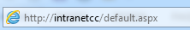
Step 1 – Start your Browser
Browser starts and the “Address” field is displayed:

Step 2 – Start SIRS
Type the URL for SIRS in the “Address” field: https://sirs.scsa.wa.edu.au
and press Enter. The “Launch Student Information Records System” screen appears:
Step 3 – Log in to SIRS
Click: . The Login screen appears:
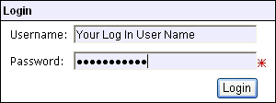
Enter your User Login ID – this will be a p followed by your school code, and may have an alpha character at the end, i.e. p1234b

Enter your Password – this should be a minimum of 8 digits, with at least one capital letter and one number.

You cannot leave either of these fields blank
The nominated person at your school with the p**** and no alpha character, has authority to grant access to extra users on SIRS.
Click .
The “Welcome to SIRS” screen appears with the main menu bar above, and important dates below:
Step 4 - Navigate to Uploads. Click on Upload Students.
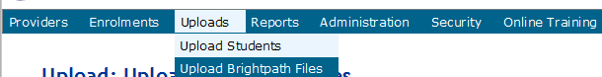

Step 5 - Click on Browse and locate your previously saved file.
Double click on this file and it will populate the field named File.
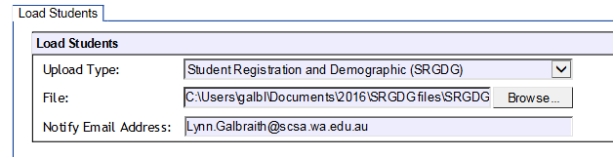
Click on Upload File For Processing
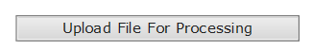

The file will be verified initially to ensure it meets a number of requirements (it must be a .csv file, the date of birth format is correct, postcodes are correct etc.). The person uploading the file will receive an email every time a file is uploaded.
- If the file fails verification – the errors must be fixed before re-uploading.
- If the file is successfully verified but fails processing – the errors must be fixed before re-uploading
- If the file successfully processes with warnings, you may need to contact the Authority to fix a date of birth/name – or the warnings may be self-explanatory and no further action required.
Successful upload
Data not uploaded successfully
Time to update data in SIRS – re-upload
Processed with warnings
Your school may not have data for this section
Locked to schools - no further uploads to the SIRS database
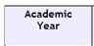
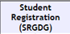
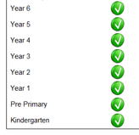
Your upload details can be seen from the SIRS Welcome Page (Secondary) or the Upload page (Primary).

For schools piloting the SRMS, please refer to your guide for dashboard navigation to view status of student registrations.

