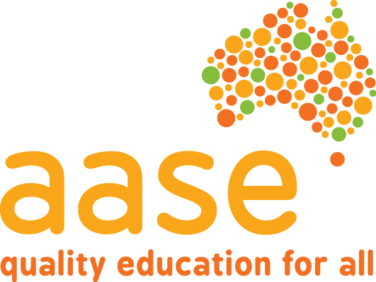
AUSTRALIAN ASSOCIATION OF SPECIAL EDUCATION Inc. WA CHAPTER

Using the Seesaw Plus app to track IEP goals in the special needs classroom
Seesaw Plus (a classroom app) has a new exciting feature that has the potential to transform the way we track student progress in special needs education.
The new “Skills” feature now allows teachers to tag posts with fully-customisable individualised learning goals and assign a simple 1-4 star rating to get a real-time understanding of how students are progressing in their IEPs. In other words, teachers can tag alternative and modified forms of assessment such as photos, videos, voice recordings, drawings, and screen-casts to specific IEP objectives, including a support level or other skill rating of your choice.
Many schools are already using Seesaw, in fact, Seesaw is used in over 200,000 classrooms and 1 in 4 schools in the US, and for good reason. The pervasiveness of this app can be attributed to the way it empowers students to take ownership of their own learning, reflect on their progress over time, and demonstrate what they know in a way that works best for them. The app teaches 21st century skills, encourages parents to participate in their child’s learning, and provides an audience that extends beyond the classroom.
This PD will focus on only one (albeit very powerful) feature; using Seesaw for formative and summative assessment of IEP goals.

Speakers: Rachel Jones
Rachel Jones is special needs educator at Cannington Community Education Support Centre and has a particular interest in classroom technologies to support and augment student learning. She has a passion for inclusivity and improving assessment practices in special needs education. She is the coordinator for the Education Support South Network (ESSN) Pedagogy Project, in which they are looking at what best practice looks like in education support, with the ultimate goal of making videos for a teacher channel. She has produced an all-inclusive podcast for the school called Retro Radio.
Her educational background is in Psychology with the following qualifications, Bachelor of Psychology (Honours) from Curtin University and Diploma of Education from UWA.

Wednesday 29th November 2017
4.00 pm – 4.30 pm Registration/refreshments
4.30pm – 6.00pm Presentation

Venue: Catholic Education WA, 50 Ruislip St, Leederville
Studio Curious

Cost: AASE Members: $20.00 (max of 3 people per group membership)
Non Members: $40.00 (payment on the day)
Invoices for organizations/schools are available if requested one week prior to the event.
Please bring organization/school cheques with you on the day of the seminar.

Afternoon tea will be provided.

Registration by 22nd November 2017 to: Mark Bivens email: mbivens@iinet.net.au
Enquiries to Julie Halvorson on: julie.halvorson@cewa.edu.au
If cancellation is necessary please advise Mark Bivens

