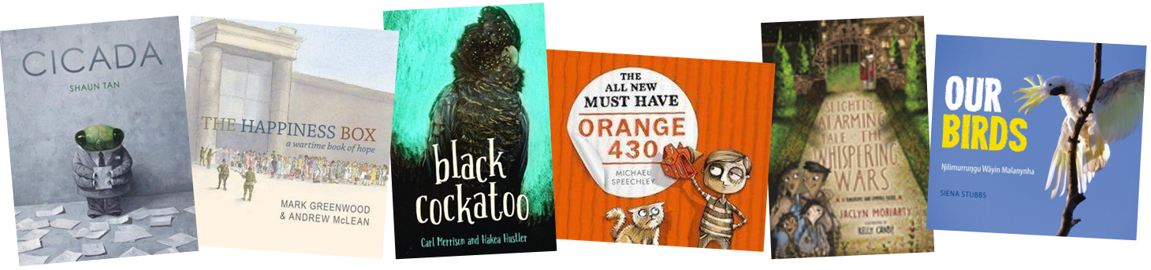

The Children’s Book Council of Australia WA Branch (Inc.)
2019 CBCA Book of the Year Awards Judges Talks
CBCA Judges Anne-Marie Strother (Older Readers)
and Felicia Harris (Younger Readers),
discuss the 2019 CBCA Book of the Year Awards Short List
Light refreshments provided
Professional Learning certificates available on request
CBCA members $5 / Non-members $15
https://www.trybooking.com/BBQJK

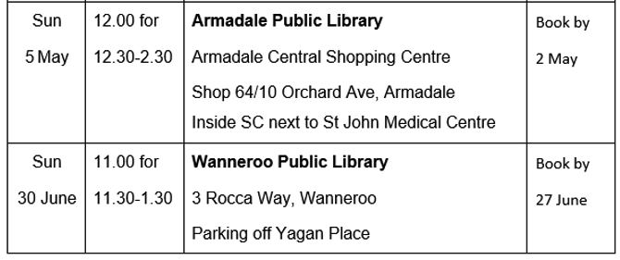
For further details, contact:
Felicia.Harris@education.wa.edu.au


