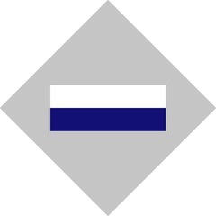
History of the 2/16th Battalion: formed in Western Australia in 1940, serving in WW 11 in the Middle East Campaign and Kokoda

An opportunity for your students to read, remember, connect and commemorate.

The2/16th Battalion Association (www.2nd16thassoc.com.au) wishes to donate books to West Australian Schools, hoping to encourage younger members of our community, either through their own volition or with the guidance of their teachers, to take an interest in important historical events and thus to perpetuate the memories and achievements of those who served.

The 2/16th Battalion was raised in 1940 in Western Australia as one of the units of the 21st Australian Infantry Brigade. The 2/16th had behind it the traditions of the 16th Battalion of the 1st AIF in WWI. The 16th Battalion fought in such places as Gallipoli, Ypres and Bullecourt, while the 2/16th served in several theatres during WW11, including the Middle East and New Guinea Campaigns (involving the Kokoda Track) and Borneo.

The books on offer are:

- A Thousand Men at War by Malcom Uren
- Kokoda Lieutenant: The triumph of the 21st Brigade by William L Grayden ( AIF Platoon Commander, 1942 and President of the 2/16th Battalion Association)
- Whatever Man Dares by Lieutenant Colonel Frank Sublet DSO MC
- Warrior of Kokoda - A Biography of Brigadier Arnold Potts by Bill Edgar.

For those related to the 2/16th Battalion veterans, the book: A Thousand Men at War will be of particular interest as, for the most part, events are based on survivors’ memories and the majority of soldiers’ names, date and place of birth are listed.
If you are interested in contacting us or learning more, please phone Diana Salvaris on 0457 457 339 or Vicki Cross on 0406 904 755.

